CCAC Speech 101/Talerico
President Ronald Reagan
The Space Shuttle Challenger Tragedy Address
January 29, 1986
SPEECH TEXT | QUESTION (PARAGRAPH OF SPEECH TEXT)
1Ladies and Gentlemen, I'd planned to speak to you tonight to  report on the state of the Union, but the events of earlier  today have led me to change those plans. Today is a day  for mourning and remembering. Nancy and I are pained  to the core by the tragedy of the shuttle Challenger. We know  we share this pain with all of the people of our country. This is  truly a national loss.  2Nineteen years ago, almost to the day, we lost three astronauts in a terrible accident on the ground. But we've never lost an astronaut in flight. We've never had a tragedy like this. And perhaps we've forgotten the courage it took for the crew of the shuttle. But they, the Challenger Seven, were aware of the dangers, but overcame them and did their jobs brilliantly. We mourn seven heroes: Michael Smith, Dick Scobee, Judith Resnik, Ronald McNair, Ellison Onizuka, Gregory Jarvis, and Christa McAuliffe. We mourn their loss as a nation together.  3For the families of the seven, we cannot bear, as you do, the full impact of this tragedy. But we feel the loss, and we're thinking about you so very much. Your loved ones were daring and brave, and they had that special grace, that special spirit that says, "Give me a challenge, and I'll meet it with joy." They had a hunger to explore the universe and discover its truths. They wished to serve, and they did. They served all of us.  4We've grown used to wonders in this century. It's hard to dazzle us. But for twenty-five years the United States space program has been doing just that. We've grown used to the idea of space, and, perhaps we forget that we've only just begun. We're still pioneers. They, the members of the Challenger crew, were pioneers.  (continued on the next page)  5And I want to say something to the school children of America who were watching the live coverage of the shuttle's take-off. I know it's hard to understand, but, sometimes, painful things like this happen. It's all part of the process of exploration and discovery. It's all part of taking a chance and expanding man's horizons. The future doesn't belong to the fainthearted;  it belongs to the brave. The Challenger crew was pulling us into the future, and we'll continue to follow them.  6I've always had great faith in and respect for our space program. And what happened today does nothing to diminish it. We don't hide our space program. We don't keep secrets and cover things up. We do it all up front and in public. That's the way freedom is, and we wouldn't change it for a minute.  7We'll continue our quest in space. There will be more shuttle flights and more shuttle crews and, yes, more volunteers, more civilians, more teachers in space. Nothing ends here; our hopes and our journeys continue.  8I want to add that I wish I could talk to every man and woman who works for NASA, or who worked on this mission and tell them: Your dedication and professionalism have moved and impressed us for decades. And we know of your anguish. We share it.  9There's a coincidence today. On this day three hundred and ninety years ago, the great explorer Sir Francis Drake died aboard ship off the coast of Panama. In his lifetime the great frontiers were the oceans, and a historian later said, "He lived by the sea, died on it, and was buried in it." Well, today, we can say of the Challenger crew: Their dedication was, like Drake's, complete.  10The crew of the space shuttle Challenger honored us by the manner in which they lived their lives. We will never forget them, nor the last time we saw them, this morning, as they prepared for their journey and waved goodbye and "slipped the surly bonds of earth" to "touch the face of God."  11Thank you. | What types of Introductions are used:  (1)  (2)  What do you notice about the speech’s writing style (i.e., note, in particular, all the sentences in italics throughout the speech)  What is the anaphora in these sections:  (2)  (3)  (4)  What one word does Reagan use to bring the audience in theses sections:  (2)  (3)  What is the alliteration:  (3)  What are the metaphors in these sections:  (1)  (2)  (4)  What is the amplification:  (4)  Does the president significantly change his wording/tone in section 5 when he speaks directly to the school children of America?  What is the anaphora in these sections:  (5)  (6)  What is the antithesis in these sections:  (5)  (7)  What American value in section 6 does Reagan bring in, even in this tragedy? Why does he do this? Is it effective?  What is the parallelism:  (7)  What types of conclusions are used:  (9)  (10)  What is the simile:  (9)  Where does the final quote (an allusion) come from (read the article on the next page):  (10)

.
10 Types of Introductions | Identifying with the Audience, Identifying with the Occasion, Stating the Purpose,  Stating the Important of the Topic, Startling Statistic, Narration, Analogy,  Rhetorical Question, Quotation, Humor
12 Types of Conclusions | Summarizing, Narration, Quotation, Rhetorical Question, Personal Reference, Humor, Warning, Remedy, The Challenge, Call to Action, The Inspiration, Utopian Vision
9 Stylistic Techniques | Signposting, Parallelism, Alliteration, Metaphor, Simile, Antithesis, Gestures, Smile,  Vocal Inflection (not monotone)

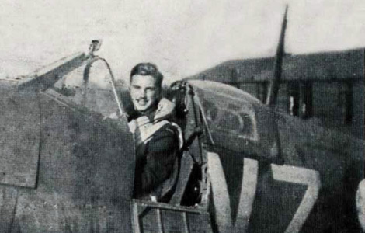

High Flight
John Gillespie Magee, Jr.
During the dark days of the Battle of Britain, hundreds of Americans crossed the border into Canada to enlist with the Royal Canadian Air Force. Knowingly breaking the law, but with the tacit approval of the then still officially neutral U.S. Government, they volunteered to fight Hitler's Germany. John Gillespie Magee, Jr., was one such American. Born in Shanghai, China, in 1922, Magee was just 18 when he entered flight training. Flying fighter sweeps over France and air defense over England against the German Luftwaffe, he rose to the rank of Pilot Officer. At the time, German bombers were crossing the English Channel with great regularity to attack Britain's cities and factories. Although the dark days of the Battle of Britain were over, the Luftwaffe was still on the job of keeping up the pressure on British industry and the country. On September 3, 1941, Magee flew a high altitude (30,000 feet) test flight in a newer model of the Spitfire V. As he orbited and climbed upward, he was struck with the inspiration of a poem—"To touch the face of God." He wrote to his parents: "I am enclosing a verse I wrote the other day. It started at 30,000 feet and was finished soon after I landed." On the back of the letter, he jotted down his poem, High Flight. Just three months later, on December 11, 1941, (and only three days after the U.S. entered the war), Magee was killed. The Spitfire V he was flying collided with an Oxford Trainer from Cranwell Airfield while over Roxholm, England. The two planes were flying in the clouds and neither saw the other. He was just 19. (source: www.skygod.com)

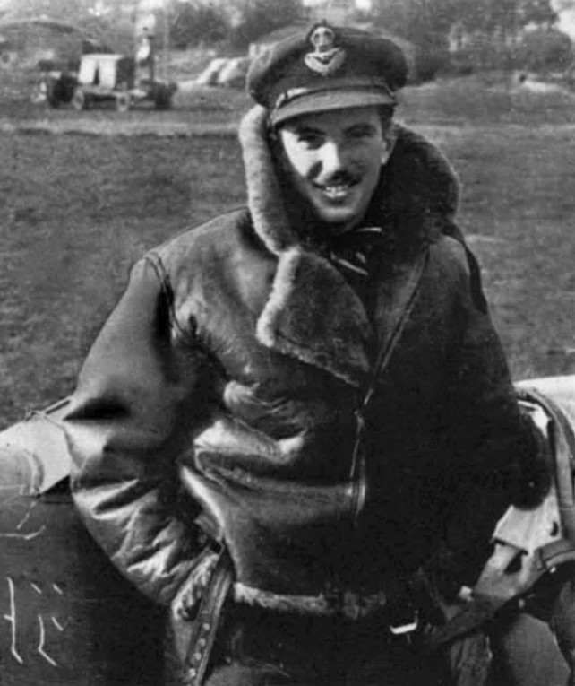
High Flight
Oh, I have slipped the surly bonds of earth
And danced the skies on laughter-silvered wings;
Sunward I've climbed, and joined the tumbling mirth
Of sun-split clouds—and done a hundred things
You have not dreamed of—wheeled and soared and swung
High in the sunlit silence. Hov'ring there,
I've chased the shouting wind along, and flung
My eager craft through footless halls of air.
Up, up the long, delirious burning blue
I've topped the windswept heights with easy grace
Where never lark, or ever eagle flew.
And, while with silent, lifting mind I've trod
The high untrespassed sanctity of space,
Put out my hand, and touched the face of God.

